Packaging Course Module 2
Lesson 1
Package Manufacturing
Review of Supply Chain
- First, we have the design house which have the building blocks (EDA Tools, foundry PDKs) to make the design of the chip. After designing we perform the IC design test program (GDSII).
- Then we have wafer fabrication where the IC design is fabricated on the wafer. The necessities are silicon wafers, manufacturing equipment, gases, chemicals, other materials.
- The next step is packaging, assembly and testing where individual ICs are assembled in a package and tested. For this we need the different substrates (leadframe, laminate, ceramic etc), tools, materials, chemicals, lids.
- Now we have the board assembly and test where many packages are assembled on boards and tested. For this we need PCBs, tools, and materials.
- Finally, we have product assembly and test where the final product is manufactured using component tools.

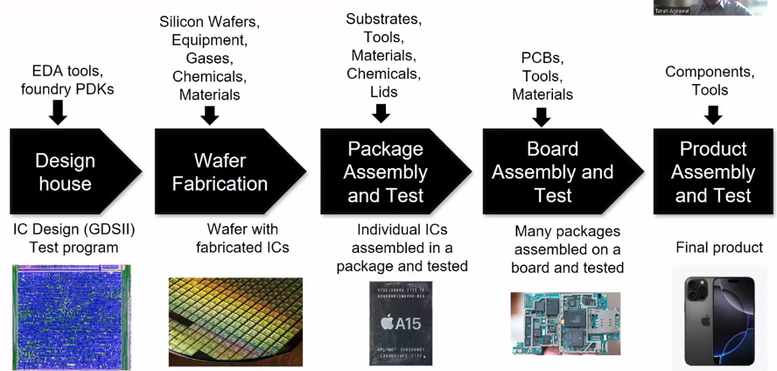

Here we are focused on the third part of the supply chain package assembly and testing. The input for this is the wafer with the fabricated IC.

Introduction of a Package Manufacturing Unit.
ATMP – Assembly, Testing, Marking and Packaging
OSAT – Outsourced Semiconductor Assembly and Test
ATMP is a process driven unit.
The ATMP unit can be in-house or it can be OSAT where the chip design is sent to an OSAT unit and they make the chip.
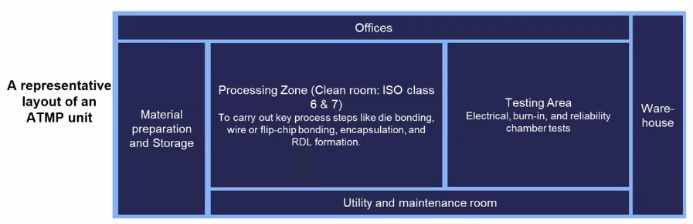
Clean room area is either measured by classes or grades and for the class the lower the number the number is the higher the cost of the unit and in grades the higher the grade is the higher the cost of building the unit is.

The clean room takes usually takes 50 – 70% of the space in the unit.
The testing area takes 20 – 30% of the space in the unit.
The utility and maintenance room is very necessary and makes sure the unit runs properly.
The material preparation and storage room holds all the materials needed for the different packaging processes.
Finally the warehouse is there to store the chips before shipping.

